69x37 mm 60 50 40

EAN Booklet
Logistic Data
Technical Data
EAN Display
EAN Carton

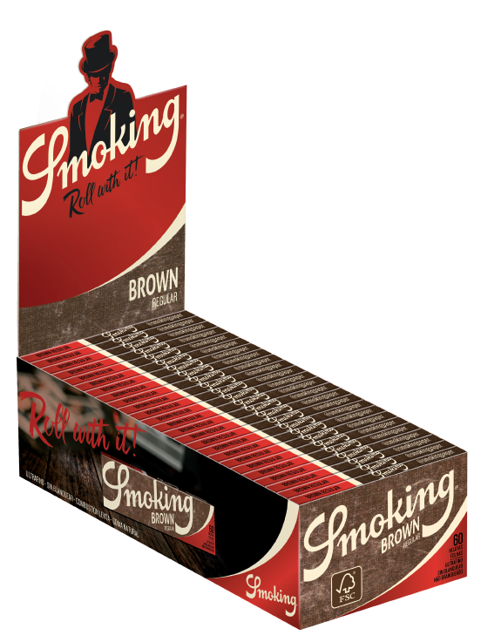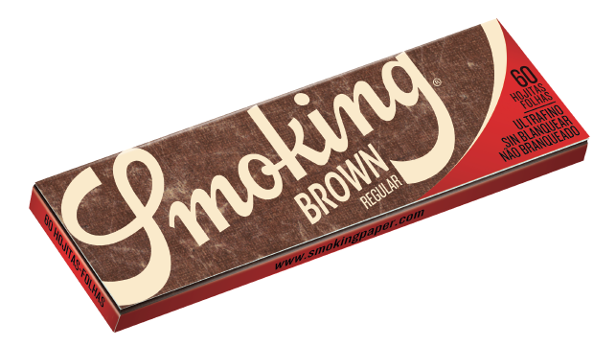
SMOKING BROWN REGULAR
34-53912
C041521
Unbleached Chlorine Free Ultrathin Paper
≈ 13 g/m²
Slow Burning
FSC® Paper
100% Natural Gum Smoking Watermark
Features

